**Student Portal Application**

|  |  |
| --- | --- |
| **V PRIYADARSHINI**  Student, Department of Computer Applications  Adhiyamaan College of Engineering (Autonomous), Hosur  Tamil Nadu, India.  priyashalini1225@gmail.com | **Dr.D.SWAMYDOSS**  HOD For Department of Computer Applications  Adhiyamaan College of Engineering (Autonomous), Hosur  Tamil Nadu, India.  [hod_mca@adhiyamaan.ac.in](mailto:hod_mca@adhiyamaan.ac.in) |

-------------------------------------------------------------------------------------------------------------------------

***Abstract:***The main objective of this project entitled "Student Portal Application" was developed to automate the manual process of the students. The student portal application project aims to provide a centralized digital platform for students to access academic resources, manage their schedules, communicate with faculty, and engage in collaborative learning activities. This application serves as a virtual hub for educational activities, offering features such as course enrollment, grade tracking, assignment submission, and forum discussions. By leveraging modern web and mobile technologies, the portal enhances the overall learning experience by fostering a more connected and interactive educational ecosystem. With intuitive user interfaces and robust backend functionalities, the student portal streamlines administrative tasks for both students and faculty, ultimately promoting efficiency, transparency, and academic success within the educational institution.

***Keywords***:Grade tracking,Assignment submission,Forum discussions.

**-------------------------------------------------------------------------------------------------------------------------**

# **I. INTRODUCTION**

The objective of the student portal project is to create a comprehensive and efficient digital platform that serves as a centralized hub for students to access essential academic resources, communicate with faculty and peers, manage their coursework, and stay informed about campus events and announcements. Through intuitive user interface design and robust functionality, the portal aims to streamline administrative processes such as course registration, grade tracking, and fee payments, enhancing overall student experience and productivity. By leveraging technology, the project seeks to foster greater engagement and collaboration within the academic community while promoting transparency and accessibility to educational opportunities and support services. Ultimately, the student portal project endeavors to empower students with the tools and information they need to succeed academically, personally, and professionally.

The student portal project aims to revolutionize the way students interact with their educational institution by providing a seamless digital experience tailored to their needs.By consolidating academic resources, administrative tasks, and communication channels into a single, user-friendly platform, the project seeks to enhance efficiency, convenience, and accessibility for students across all levels of academia. Through features such as personalized dashboards, real-time updates on grades and course schedules, and collaborative tools for group projects and discussions, the portal will empower students to take control of their learning journey and engage more actively with their studies.

**II. MODULE**

ADMIN MODULE

• Admin Login Page

• Leave Management

• Private Chat

• Student Marksheet

• Student Detail

• Academic Schedule

• E-Resource

• Leader Management

• Placement Activities

STUDENT MODULE

• Student Login Page

• Placement Activities

• Leave Management

• Private Chat

• Student Application Form

• E Resource

**III .MODULE DESCRIPTION**

ADMIN LOGIN PAGE

Login page is used for secured of the user to loss or gain, the authorized user can only log into app. The fields are

• Register Number- register number of the user logging into app

• Password- password used for logging into app

First User has to register to the app by giving his username,email, password, name. After registration he can login into the app by providing his username and password. User can add the a items and also can view the previous income and items. The registration process should be filled with consist of user email id and password can be generate with some of character, numbers and special symbols to accept the password from the user.

LEAVE MANAGEMENT

In a student portal project, Leave Management refers to the systematic process of administrating and overseeing employee absences from work. This encompasses various tasks such as requesting, approving, and tracking leave requests, ensuring compliance with company policies, labor laws, and regulations, and maintaining accurate records of employee absences

PRIVATE CHAT

In a Student Portal project, implementing a private chat feature serves as a valuable tool is a facilitating effective communication and collaboration among employees, managers, and HR personnel within the organization. Private chat functionality allows individuals to engage in one a on -one or group conversations in a secure and confidential manner, enabling them to discuss sensitive matters, seek advice, provide feedback, or address related concerns without the need for face-to-face interaction.

STUDENT MARKSHEET

The Student Marksheet Module is a fundamental component within the student portal application, designed to manage and provide access to students' academic performance records. below is a description of the key features and functionalities typically found in the Student Marksheet Module.

STUDENT DETAILS

The Student Detail Module within the student portal application serves as a comprehensive repository for managing and updating personal information of students, faculty, and staff. This module encompasses various functionalities tailored to ensure accuracy, security, and accessibility of personal details.

ACADEMIC SCHEDULE

The Academic Schedule Module within a student portal application is a centralized platform designed to manage and provide access to academic schedules, including class timetables,process examination schedules, and other important events. This module serves as a vital resource for students, faculty, and staff, ensuring clarity and organization in academic activities throughout the semester or academic year.

E RESOURCE

The E-Resource Module within a student portal application serves as a digital library or repository of electronic resources, providing students, faculty, and staff with convenient access to a wide range of educational materials, research publications, databases, and multimedia content. The resource module within a student portal acts as a centralized repository where students can access a variety of educational materials and tools to support their learning endeavors. This module typically encompasses a diverse range of resources, including lecture notes, textbooks, multimedia presentations, research articles, and interactive learning activities.

LEADER MANAGEMENT

Leader management within a Student portal project involves the strategic identification, development, and support of effective leaders within an organization. This aspect focuses on nurturing leadership qualities, providing opportunities for growth and advancement, and ensuring that leaders have the necessary skills and resources to effectively guide and inspire their teams.

PLACEMENT ACTIVITIES

The Placement Management Module within a student portal application is a vital process the component designed to facilitate the management of placement activities, career services, and job placement opportunities for students. It serves as a centralized platform where students, alumni, recruiters, and career services personnel can interact, exchange information, and coordinate various aspects of the placement process.

STUDENT MODULE

The student module within the student portal project serves as the primary interface for students to access and manage their academic journey. This module encompasses a range of features tailored to meet the needs of students, providing them with convenient tools to navigate their courses, track progress, communicate with peers and faculty, and engage with campus activities.

STUDENT LOGIN PAGE

The login page serves as the primary gateway for students to access the student portal, offering a secure and personalized entry point to various academic resources and functionalities. The student login page within a student portal serves as the gateway for students to access their personalized academic information and resources. Typically designed with simplicity and user-friendliness in mind, the login page presents a form where students input their credentials, often a combination of a username or email address and a password.

STUDENT REGISTER PAGE

The register page consists of username, password and profile of the user. Without the password no one cannot login to the website at any time or without authentication. For creating one’s user account to this website called mobile app.Coming to the username or email, one should always maintain the user name as unique way.

LEAVE MANAGEMENT

In a student portal project, Leave Management refers to the systematic process of administrating and overseeing employee absences from work. This encompasses various tasks such as requesting, approving, and tracking leave requests, ensuring compliance with company policies, labor laws, and regulations, and maintaining accurate records of employee absences.

STUDENT APPLICATION FORM

The Application Form Module within the student portal application serves as a comprehensive repository for managing and updating personal information of students, faculty, and staff. This module encompasses various functionalities tailored to ensure accuracy, security, and accessibility of personal details.

E-RESOURCE

The E-Resource Module within a student portal application serves as a digital library or repository of electronic resources, providing students, faculty, and staff with convenient access to a wide range of educational materials, research publications, databases, and multimedia content.The resource module within a student portal acts as a centralized repository where students can access a variety of educational materials and tools to support their learning endeavors.

PRIVATE CHAT

In a Student Portal project, implementing a private chat feature serves as a valuable tool is a for facilitating effective communication and collaboration among employees, managers, and HR personnel within the organization. Private chat functionality allows individuals to engage in one a on-one or group conversations in a secure and confidential manner, enabling them to discuss sensitive matters, seek advice, provide feedback, or address related concerns without the need for face-to-face interaction.

**IV. SYSTEM REQUIREMENTS**

HARDWARE REQUIREMENTS

Minimum Requirement

•Processor : Intel Core i5

•Speed : 1(ghz) and Above

•RAM : 8 GB and Above

•Monitor : 15.6

•Input Devices : Keyboard,Touchpad

SOFTWARE REQUIREMENT

Minimum Requirement

•Operating system : Windows 11

•Frontend : XML

•Backend : Android(Java)

•IDE : Android Studio-2

•Database : Php

**V. TECHNOLOGY OVERVIEW**

PHP

PHP is the most popular server-side language used to build dynamic websites, and though it is a very extensive language, this class will take it step-by-step. The stateless web (HTML, CSS and JavaScript) can only do so much without a dynamic language such as PHP to add the ability to interact with the web server. You will learn how to make your page’s dynamic based upon user interaction, interacting with HTML forms and store and retrieve information from local data sources which include a database.

The only complete PHP implementation is the original, known simply as PHP. It is the most widely used and is powered by the Zend Engine. To disambiguate it from other implementations, it is sometimes unofficially called "Zend PHP". The Zend Engine compiles PHP source code on-the-fly into an internal format that it can execute, thus it works as an interpreter. It is also the "reference implementation" of PHP, as PHP has no formal specification, and so the semantics of Zend PHP define the semantics of PHP.

XAMPP SERVER

XAMPP is a free and open-source cross-platform web server solution stack package developed by Apache Friends. The name XAMPP stands for cross-platform (X), Apache (A), MySQL (M), PHP (P), and Perl (P). It includes a collection of software components that are commonly used to develop dynamic web applications locally. The core components of XAMPP include the Apache HTTP Server, MySQL database server, PHP programming language, and Perl programming language.

XAMPP is designed to be easy to install and configure, making it an ideal solution for developers, students, and hobbyists looking to set up a local web development environment quickly. It provides a bundled package of server software that eliminates the need to install and configure each component individually. Additionally, XAMPP comes with a control panel that allows users to start, stop, and configure the various services included in the stack with ease.

MYSQL

MySQL is an open-source relational database management system (RDBMS). Its name is a combination of "My", the name of co-founder Wideness’s daughter, and "SQL", the abbreviation for Structured Query Language.

A relational database organizes data into one. Or more data tables in which data types may be related to each other; these relations help structure the data to get on the database to control and the on if. This can be implemented to relational database to creation on it. 21 In our project, we harness the capabilities of Structured Query Language (SQL) to efficiently manage and interact with our database. SQL acts as the foundation of our data management system, seamlessly organizing, retrieving, and manipulating information. By utilizing SQL queries, we are able to execute a range of operations including data insertion, record updates, and extraction of pertinent information for analysis.

**VI. SCREEN LAYOUTS**

**STUDENT LOGIN PAGE**

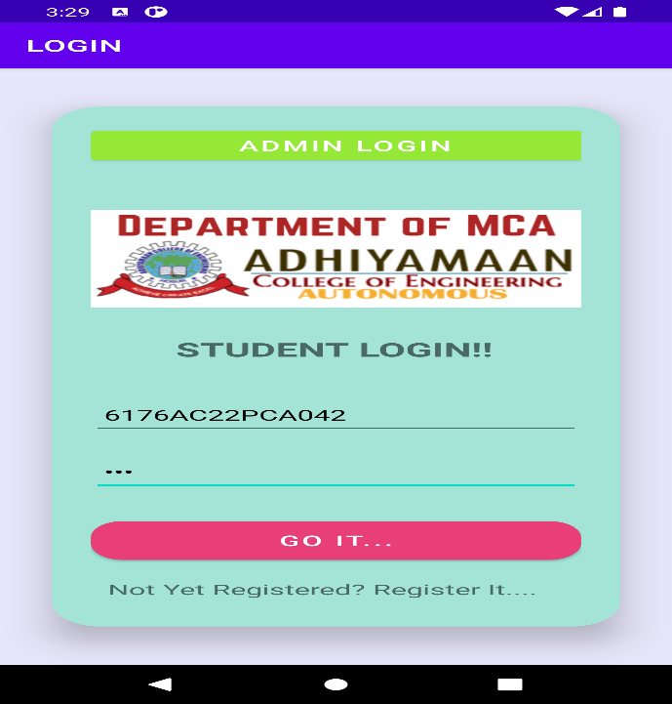

**STUDENT REGISTER PAGE**

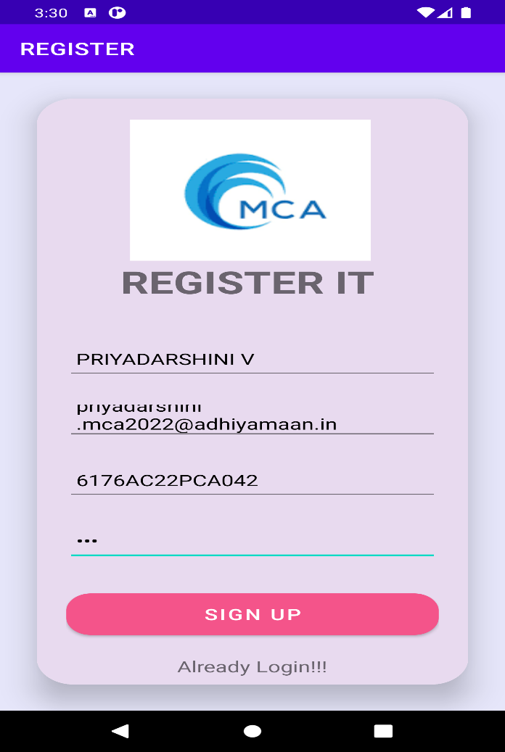

**STUDENT HOME PAGE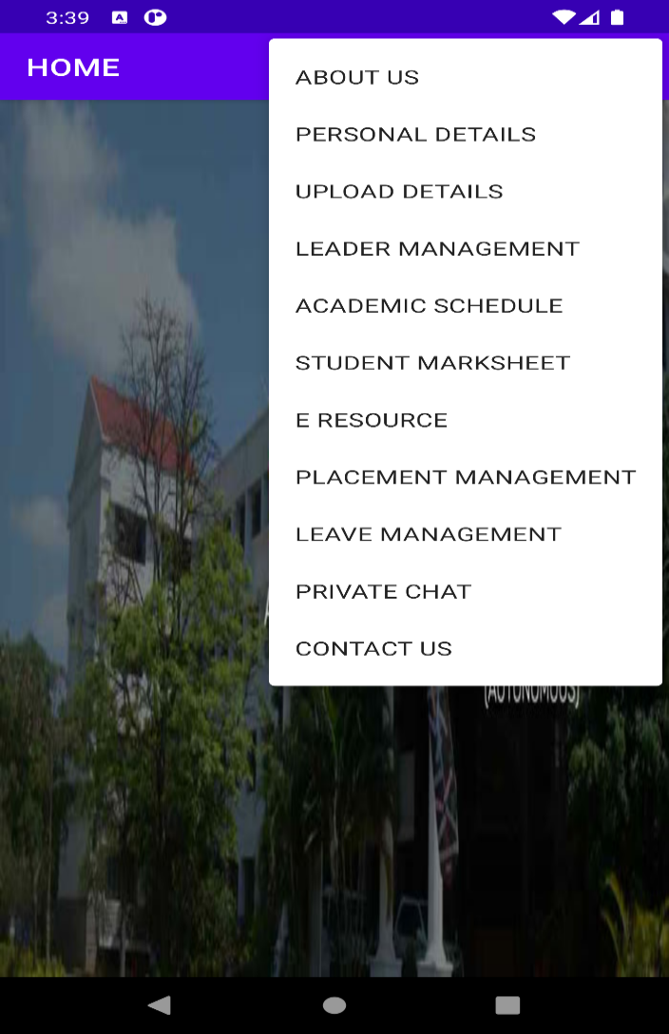ABOUT PAGE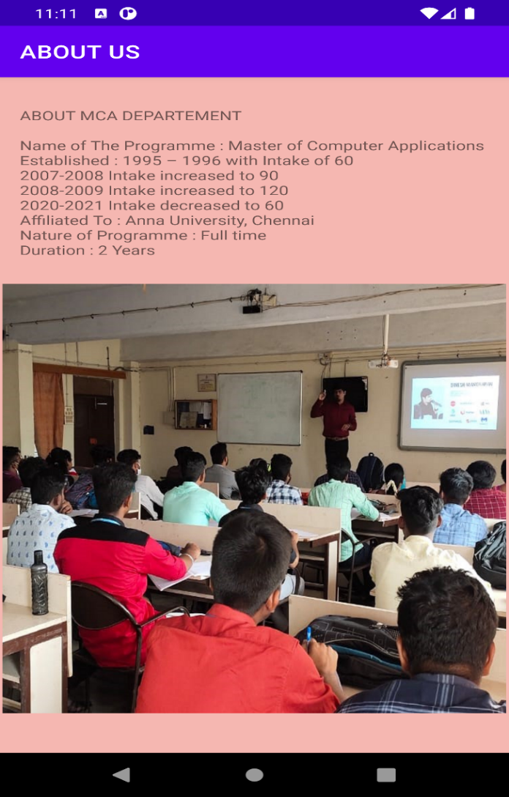PRIVATE CHAT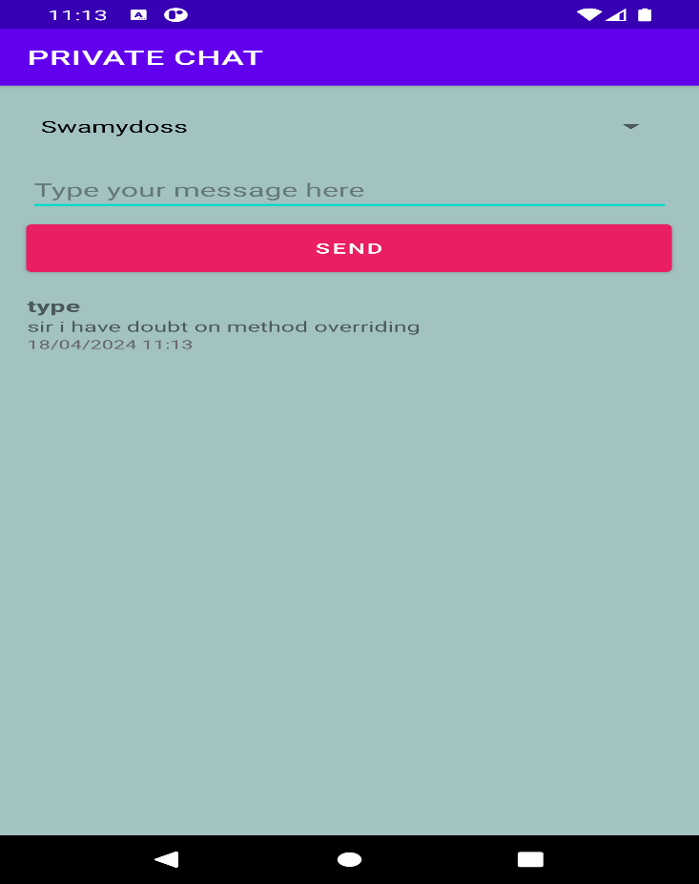STUDENT PERSONAL DETAIL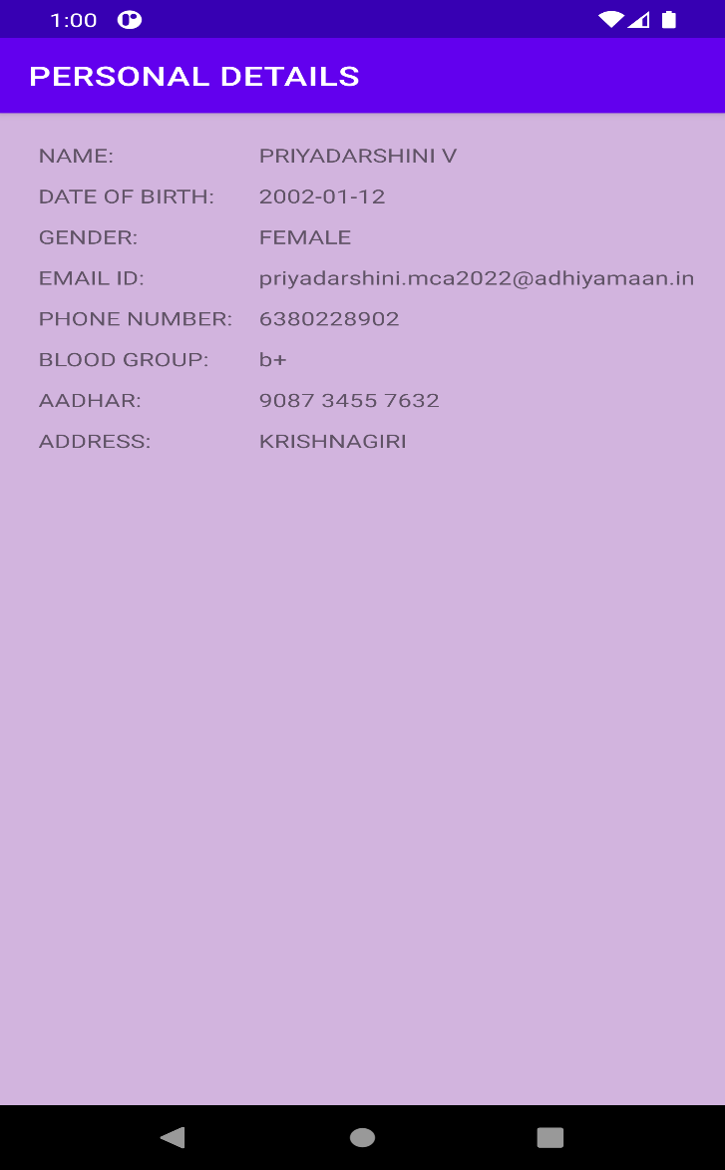LEADER MANAGEMENT**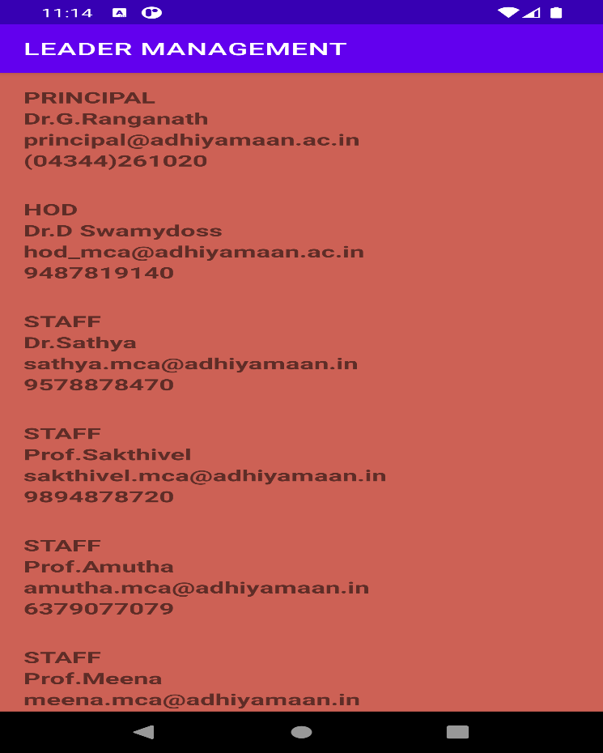

**ACADEMIC SCHEDULE**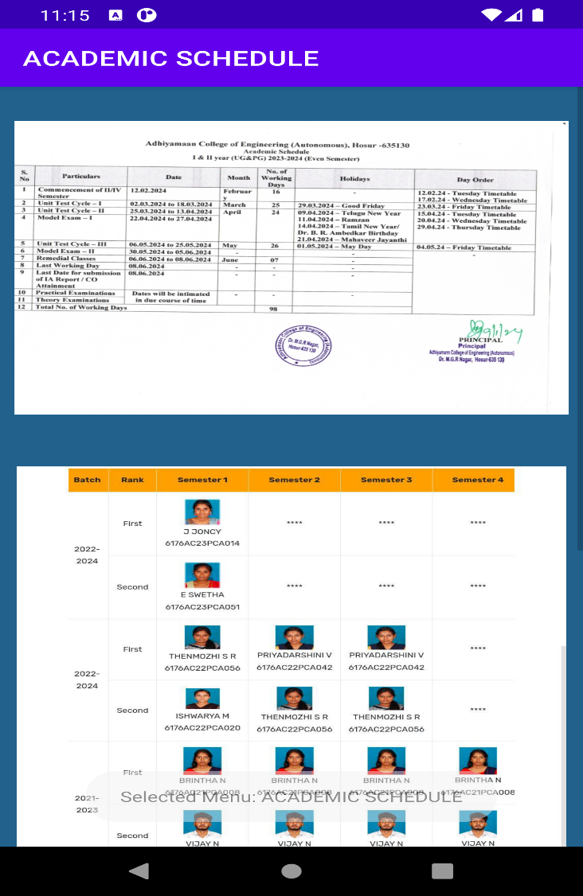

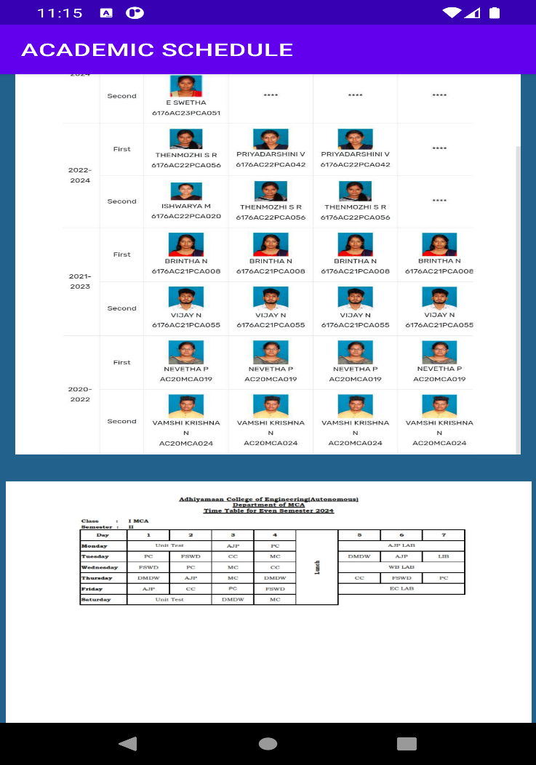**E RESOURCE**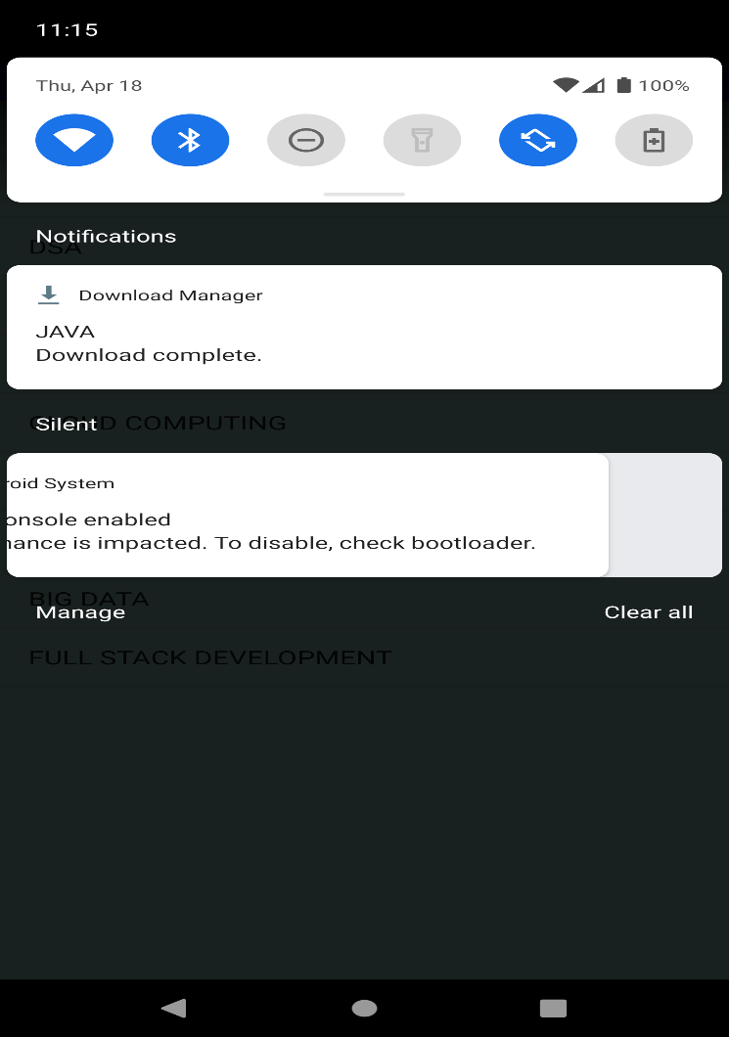

**PLACEMENT MANAGEMENT**

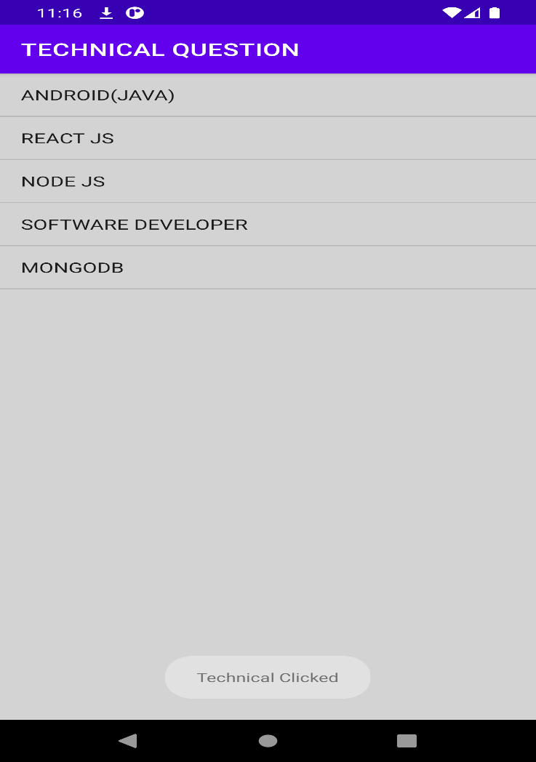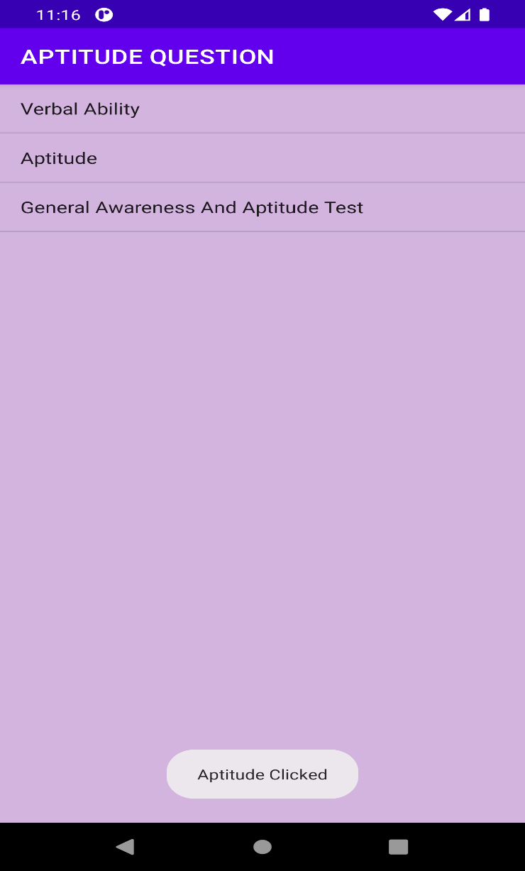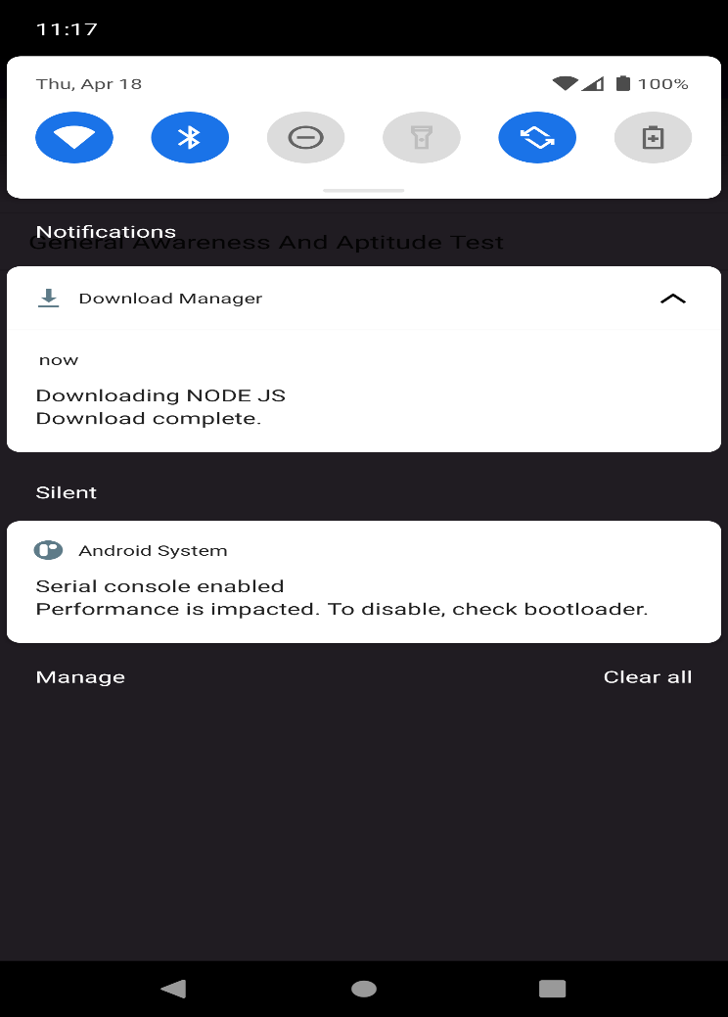**LEAVE MANAGEMENT**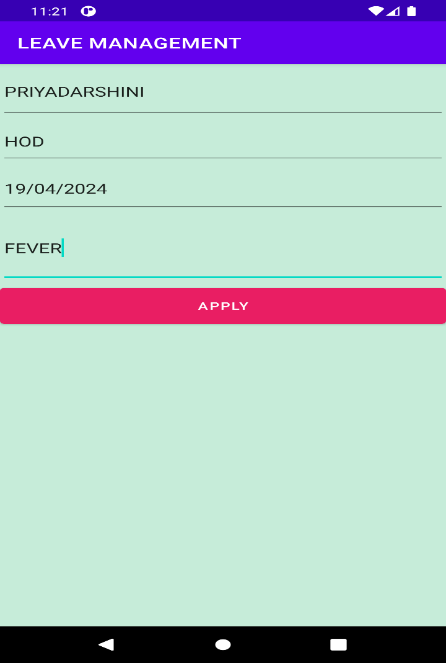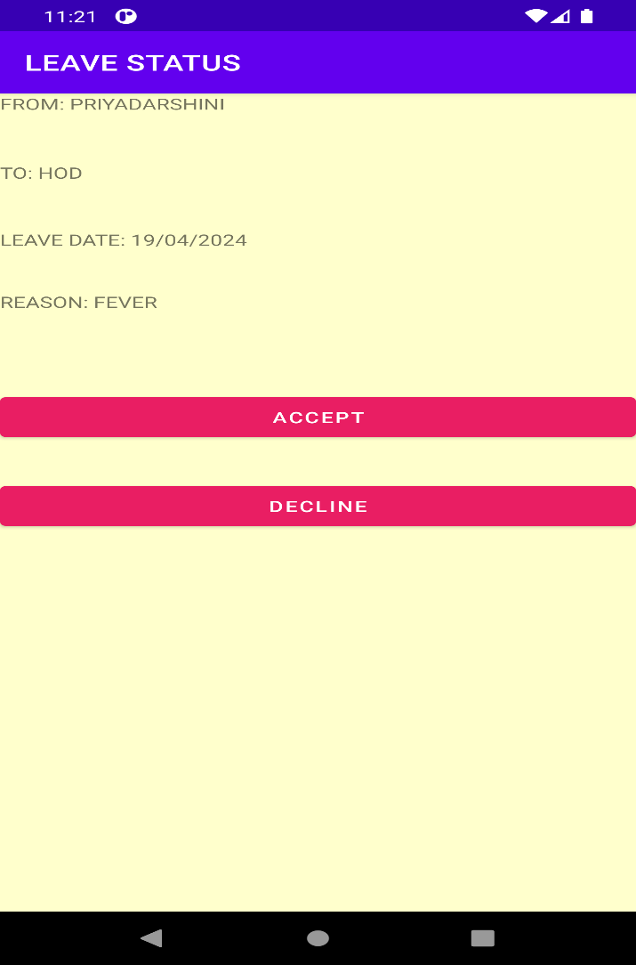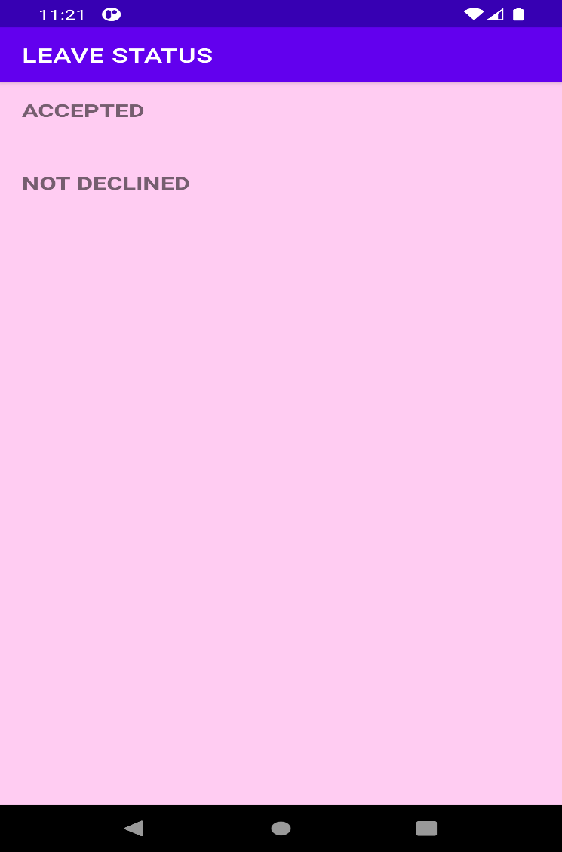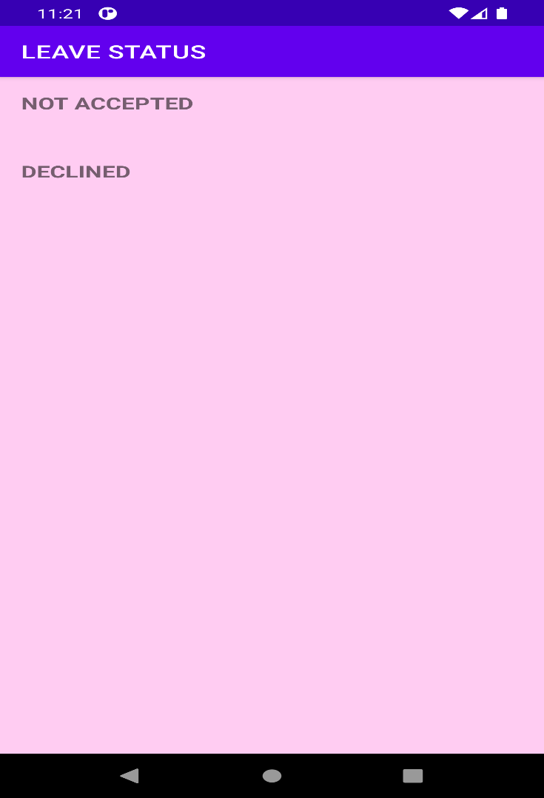

**STUDENT MARKSHEET**

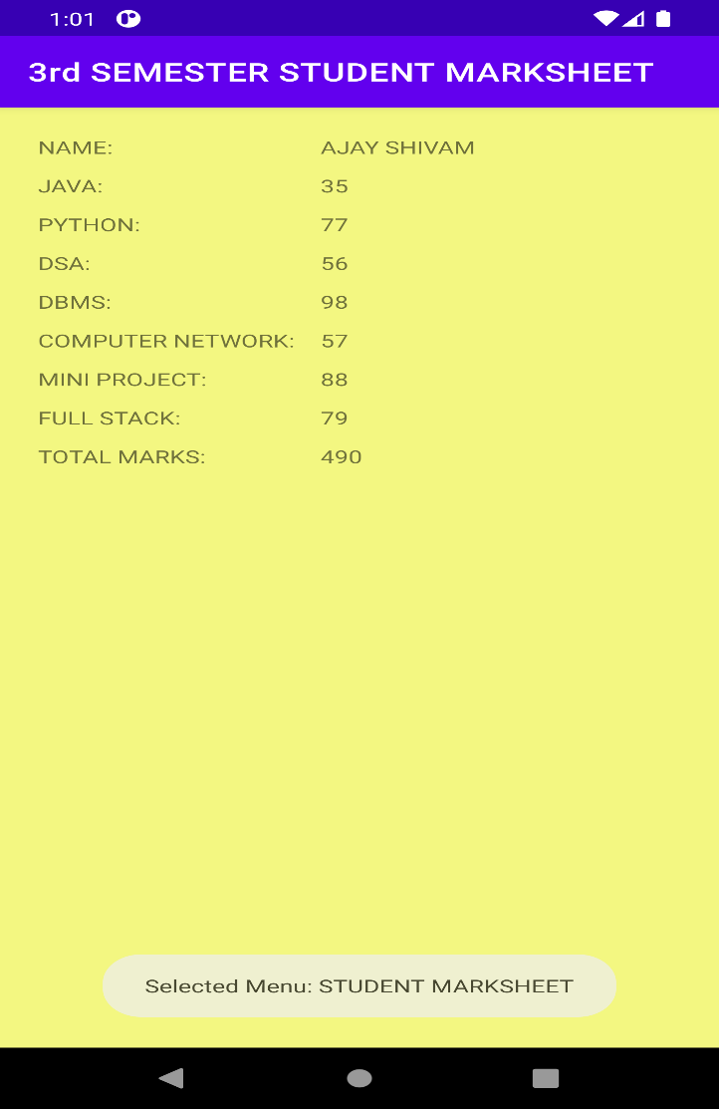

**ADMIN LOGIN PAGE**

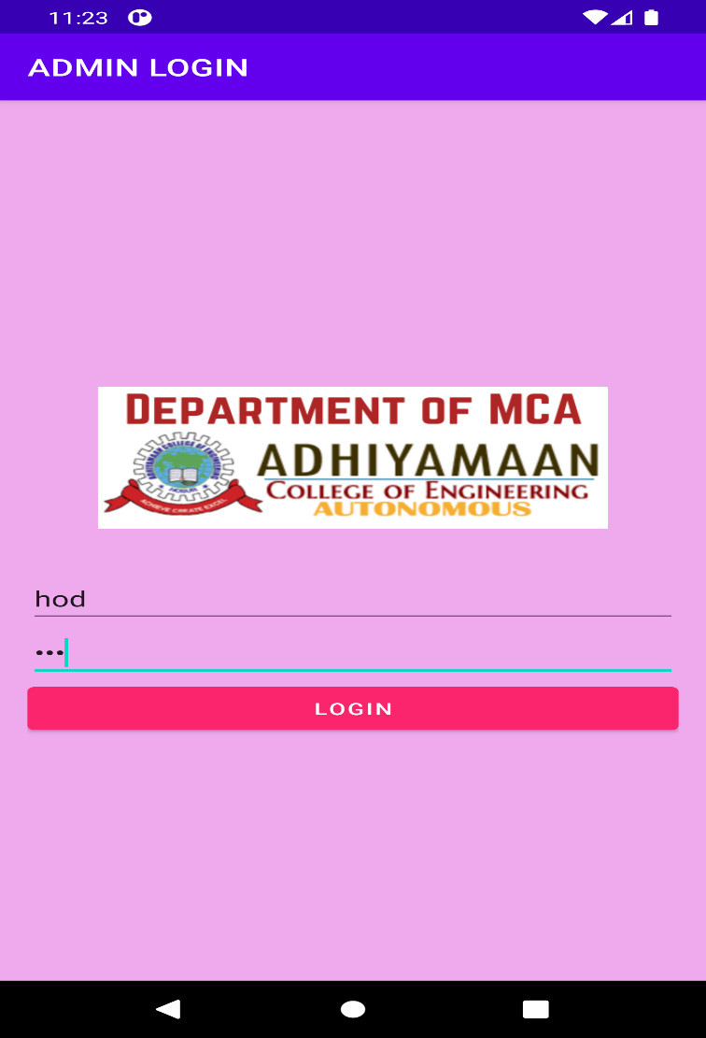

**ADMIN HOME MENUS**

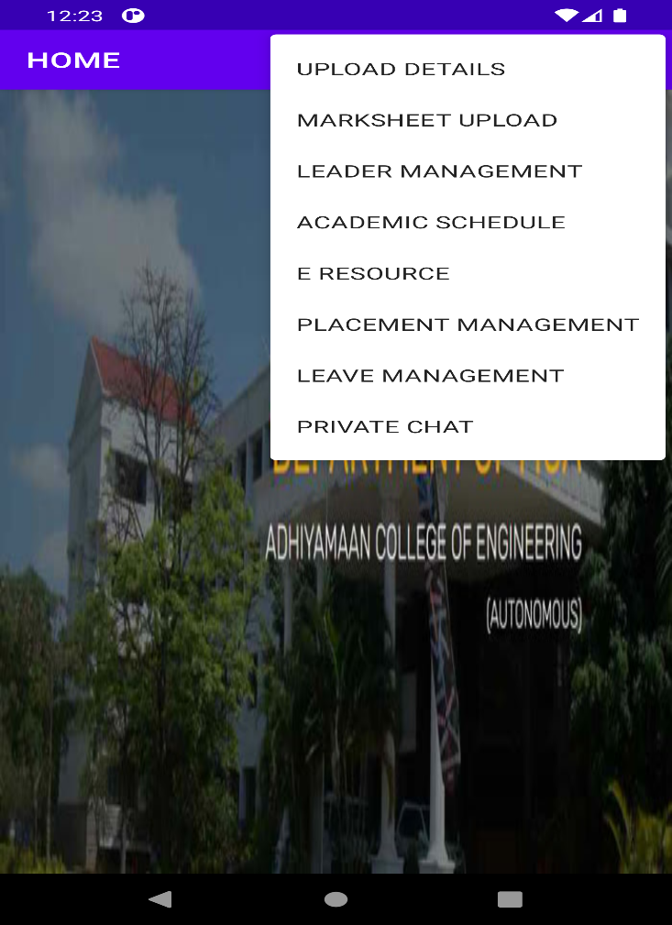

**ADMIN UPLOAD STUDENT DETAILS**

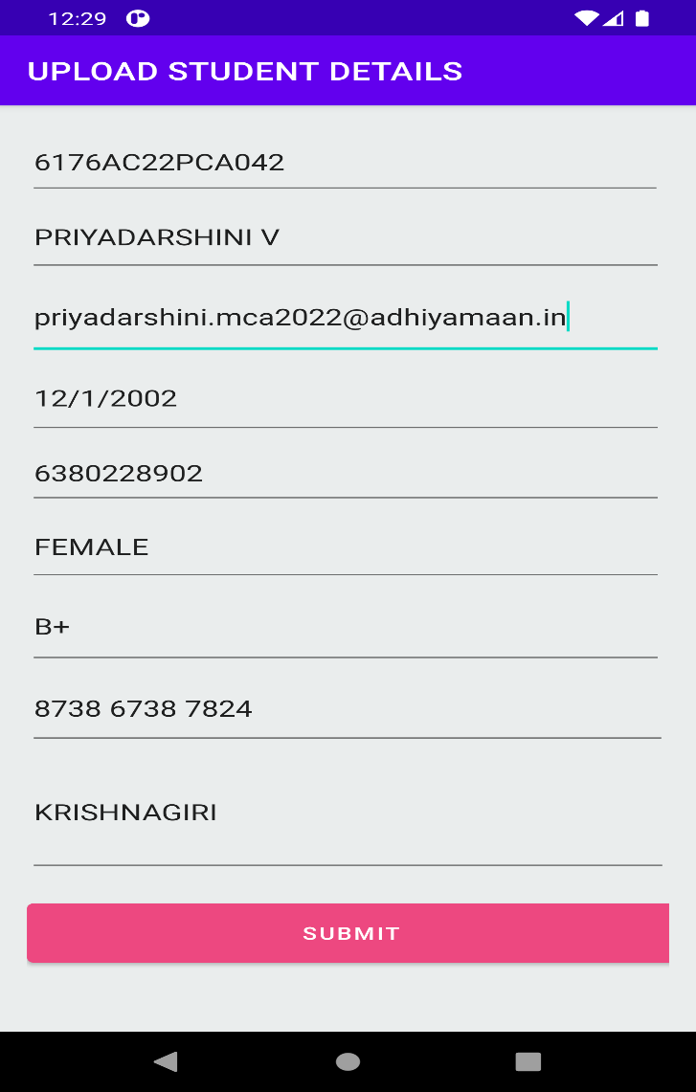

**ACADEMIC SCHEDULE UPLOAD**

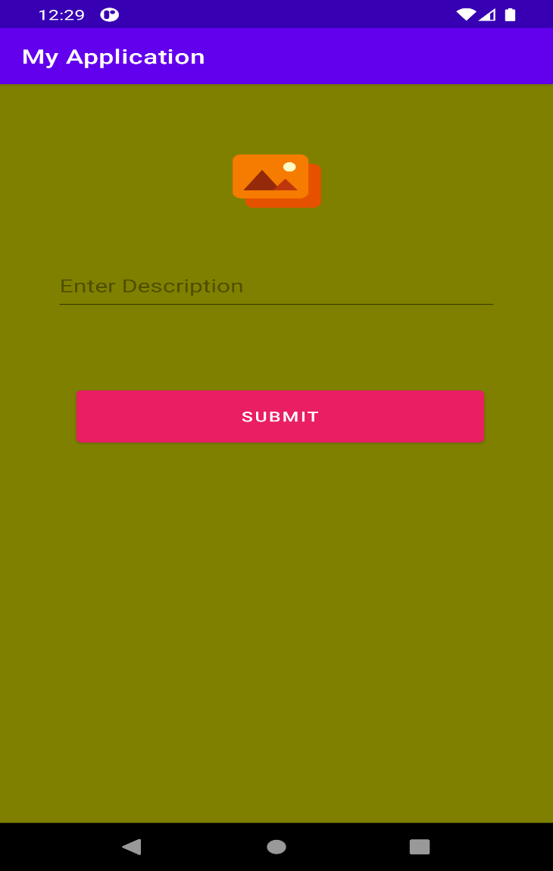

**ADMIN UPLOAD STUDENT MARKSHEET**

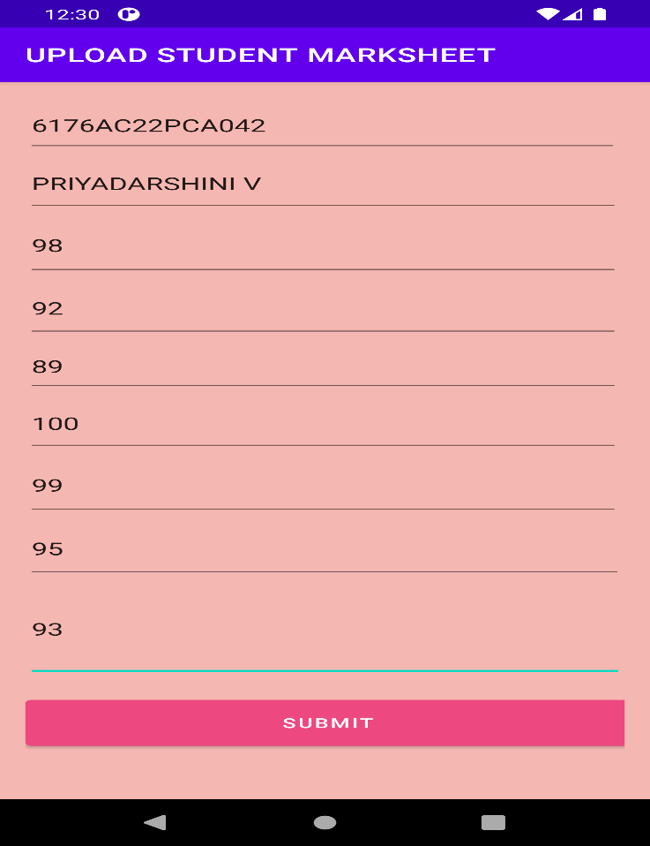

**VII. CONCLUSION**

In conclusion, the development of the student portal application marks a significant milestone in enhancing the educational experience for both students and faculty. Through this project, we have successfully created a user-friendly platform that centralizes essential academic resources, communication channels, and administrative functions. By streamlining access to information and facilitating seamless interaction, the portal has contributed to increased efficiency and productivity within the educational institution. Moving forward, there are several avenues for future enhancement.

**APPENDIX**

Creating an appendix for your student portal application project can be a valuable addition. It helps provide supplementary information that supports your project, such as diagrams, code snippets, user manuals, or any other relevant documentation.

**ACKNOWLEDGMENT**

We extend our sincerest gratitude to all who contributed to the realization of this student portal application. Our heartfelt thanks go to our esteemed faculty mentors for their invaluable guidance and support throughout the project's development. Special appreciation is also extended to our dedicated beta testers and peer collaborators for their valuable feedback and collaboration. We are grateful for the resources and opportunities provided by [Adhiyamaan College Of Engineeing], as well as the support of our family, friends, and the open-source community. This project stands as a testament to the power of teamwork, mentorship, and community, and we are truly thankful for the collective effort that made it possible.

**REFERENCES**

1. Duckett, J. (2014). "Web Development with HTML, CSS, and JavaScript." John Wiley & Sons.
2. Ramakrishnan, R., & Gehrke, J. (2002). "Database Management Systems." McGraw-Hill Education.
3. Nielsen, J., & Loranger, H. (2006). "Prioritizing Web Usability." New Riders.
4. Cooper, A., Reimann, R., & Cronin, D. (2007). "About Face 3: The Essentials of Interaction Design." John Wiley & Sons.
5. Martin, R. C. (2009). "Clean Code: A Handbook of Agile Software Craftsmanship." Prentice Hall.
6. Gamma, E., Helm, R., Johnson, R., & Vlissides, J. (1994). "Design Patterns: Elements of Reusable Object-Oriented Software." Addison-Wesley
7. Freeman, E., Robson, E., & Bates, B. (2004). "Head First Design Patterns." O'Reilly Media.
8. Hunt, A., & Thomas, D. (1999). "The Pragmatic Programmer: Your Journey to Mastery." Addison-Wesley.
9. Fowler, M. (2002). "Patterns of Enterprise Application Architecture." Addison-Wesley.

**AUTHOR PROFILE**



**V PRIYADARSHINI**

**FINAL YEAR OF MCA STUDENT**

**ADHIYAMAAN COLLEGE OF ENGINERING**

**HOSUR**